# dSQL Functions

## Create Table

Create table dest_tbl_1

(empid number,

Empname varchar2(50) ,

date_of_hire date)

## Create Table from Another Existing table

CREATE TABLE EMPLOYEE AS

SELECT EMPNO, ENAME, SAL, HIREDATE

FROM EMP

SELECT * FROM EMPLOYEE

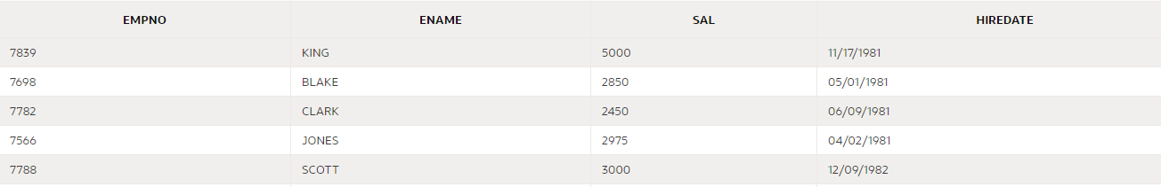

## DESCRIBE

DESCRIBE EMP; DESC EMP

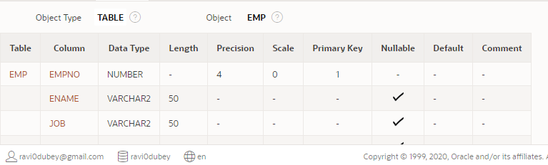

## ALTER

alter table dest_tbl_2

modify

(empid number(4),

Empname varchar2(50) ,

date_of_hire date)

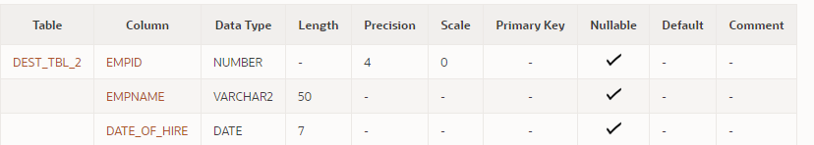

To add Primary Key

alter table dest_tbl_3

modify

(empid number,

Empname varchar2(50) ,

date_of_hire date,

constraint pk_key1 primary key(empid))

or

To add Primary Key column

ALTER TABLE stores

ADD CONSTRAINT store_id_pk PRIMARY KEY (store_id)

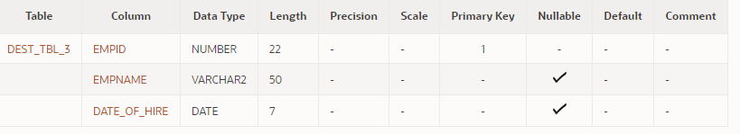

To rename a field

ALTER TABLE DEST_TBL_3

RENAME COLUMN EMPNAME to EMP_NAME

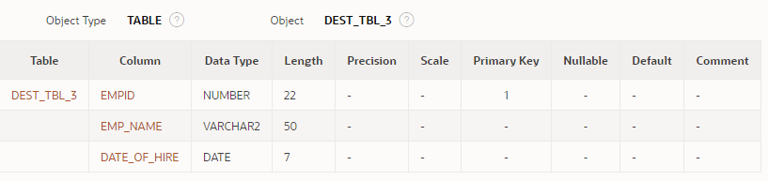

To ADD a column

ALTER TABLE EMPLOYEE

ADD (MANAGER VARCHAR2 (10))

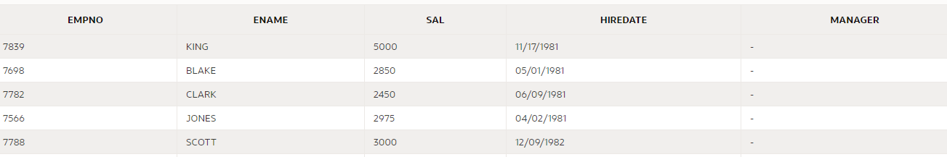

ATLER TABLE EMPLOYEE

DROP CONSTRAINT SYS_C0001

To Drop a constraint

ALTER TABLE PRODUCTS

DROP CONSTRAINT fk_supplier

To add a constraint

ALTER TABLE PRODUCTS

ADD CONSTRAINT fk_supplier

FOREIGN KEY (supplier_id)

REFERENCES supplier(supplier_id)

ON DELETE CASCADE

To drop single column

ALTER TABLE SUPPLIER DROP (contact_name)

To drop multiple column together

ALTER TABLE SUPPLIER DROP (contact_name, supplier_name)

## UPDATE

UPDATE EMPLOYEE

SET MANAGER = 'KING'

WHERE ENAME IN ('BLAKE','CLARK','JONES','SCOTT')

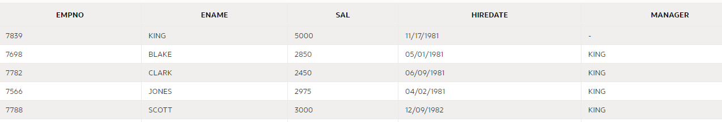

## CONCAT

select concat(concat(ename,upper(' is the Name')), concat(' and their job is: ', JOb)) as Name from emp

OR

SELECT EMPNO AS "Employee Number”, Ename ||' Makes ' ||Sal as "Salary"

FROM EMP

WHERE job = 'SALESMAN' AND (COMM = 300 OR COMM > 1000)

## INITCAP -> It Upper Case first Letter of each word

SELECT INITCAP ('hello my name is Ravi') as Variable

FROM DUAL

**Output**



## LENGTH-> It will give length of data in each field

SELECT Ename, length(Ename) as Length from Emp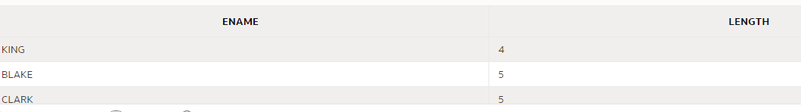

## LPAD -> it will do padding of extra spaces with value specified

SELECT LPAD (ENAME, 10, '%') AS NAME

FROM EMP

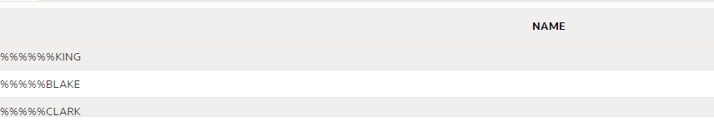

## RPAD

select RPAD(ENAME, 10, '%') AS NAME

FROM EMP

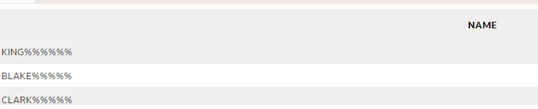

## ROUND

SELECT ROUND (123.88, 1) FROM DUAL;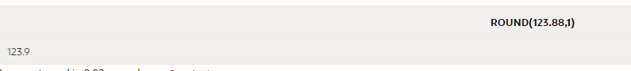

## Add months

select add_months('06/25/2020', 3) from dual;

select add_months('06/25/2020', -3) from dual;

select add_months(sysdate, -3) from dual;

## Months_Between

select months_between(sysdate,'03/07/2020') from dual;



## Trunc

select hiredate, trunc(hiredate,'month'), trunc(hiredate,'Year') from emp

Trunc with month will give first date of the month

Trunc with year will give first date of year

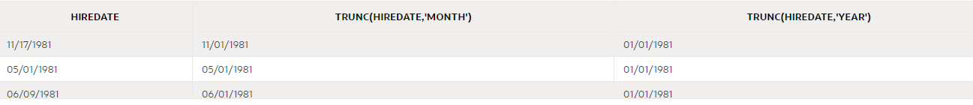

## TO_CHAR

SELECT TO_CHAR (SYSDATE, 'Month day year') from dual;

SELECT TO_CHAR (SYSDATE, 'Month_DD,YYYY') from dual;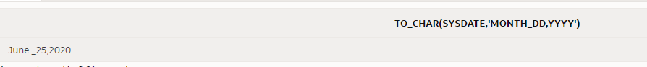

SELECT SAL, TO_CHAR(SAL, '$9999.00') AS Salary from EMP;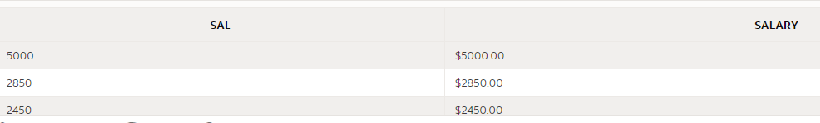

SELECT TO_CHAR(19678.99,'$99,999.99') FROM DUAL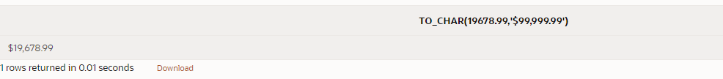

## ToDate

SELECT TO_DATE('2020-06-27','YYYY-MM-DD') FROM DUAL

OR

SELECT TO_DATE('27 OF JUNE, 2020','DD "OF" MONTH, YYYY')

FROM DUAL

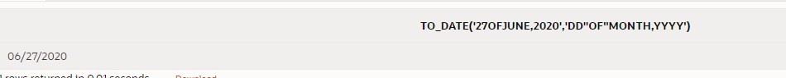

## NVL-> Null Value used for Integer values

select comm, nvl(comm, '0')

from emp;

It replaces null value with provided value in this case 0

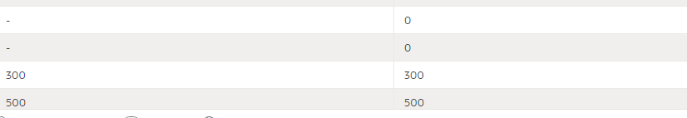

select comm, nvl(to_Char(comm),'Data not found')

from emp;

It replaces null value with String “Data not Found “

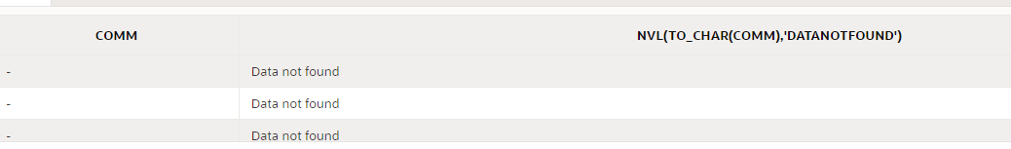

## NullIF

select eName, nvl(to_Char(nullif(length(eName),5)),'Length is 5')

from emp;

If length is 5 it replaces with output to Character string “Length is 5”

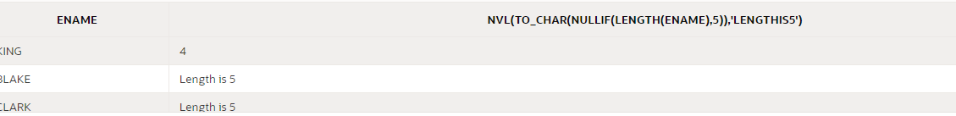

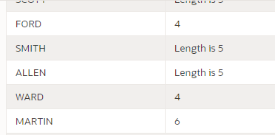

## Manager with Maximum Salary

SELECT * FROM EMP

WHERE SAL =

(SELECT MAX (SAL)

FROM EMP

WHERE JOB = 'MANAGER');



## Managers having Salary greater than Average Salary drawn by all Managers

SELECT * FROM EMP

WHERE job = 'MANAGER'

AND SAL >

(SELECT AVG (SAL)

FROM EMP

WHERE JOB = 'MANAGER');

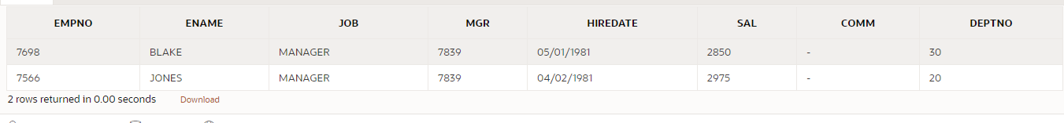

## Average Salary of each Job

SELECT JOB, AVG (SAL)

FROM EMP

GROUP BY JOB

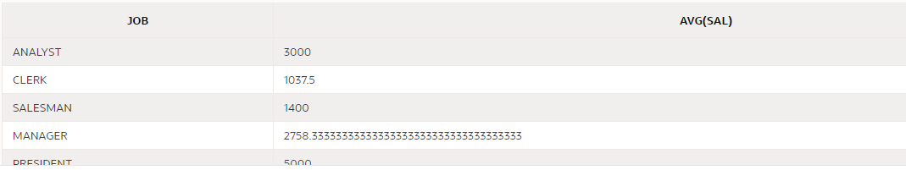

## Job where Count of employee is 2.

select job, count(job) as countnum from emp

group by job

having count(job)= 2

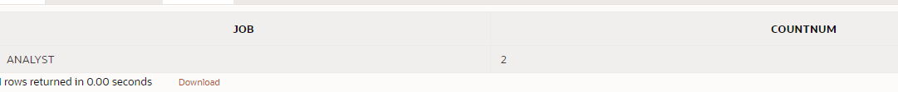

## Department where Count of employee is greater than 3 in that Department.

select deptno, count(*) as Number_Employee from emp

group by deptno

having count(*)> 3

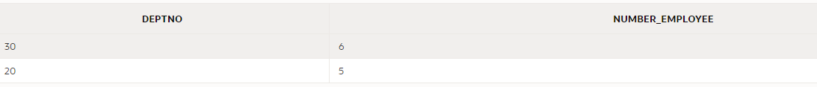

## Employees who work in Dallas.

SELECT A.*

FROM EMP A JOIN DEPT B

ON A.DEPTNO = B.DEPTNO

WHERE UPPER (B.LOC) = 'DALLAS'

OR

SELECT A.* FROM

(SELECT * FROM EMP WHERE JOB in ('MANAGER', 'CLERK')) A,

(SELECT * FROM DEPT WHERE UPPER (LOC) = 'DALLAS') B

WHERE A.DEPTNO = B.DEPTNO

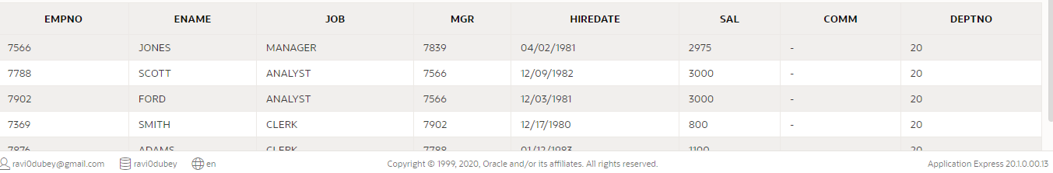

## Left Join.

SELECT * FROM

EMP A LEFT JOIN DEPT B

ON A.DEPTNO = B.DEPTNO

WHERE UPPER (B.LOC) = 'DALLAS'

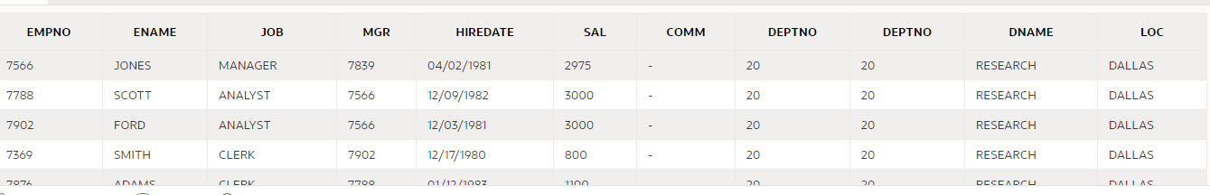

## RIGHT Join.

SELECT * FROM

EMP A RIGHT JOIN DEPT B

ON A.DEPTNO = B.DEPTNO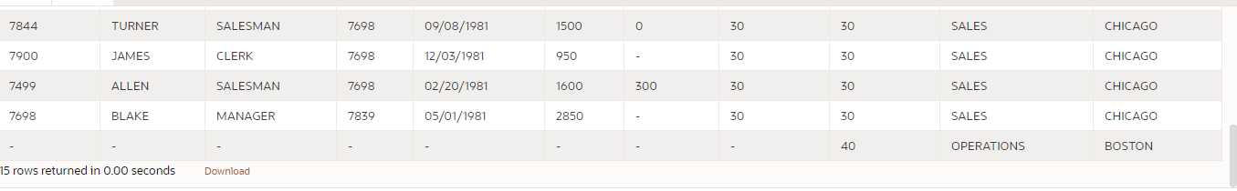

## FULL OUTER JOIN

SELECT * FROM

EMP A FULL OUTER JOIN DEPT B

ON A.DEPTNO = B.DEPTNO

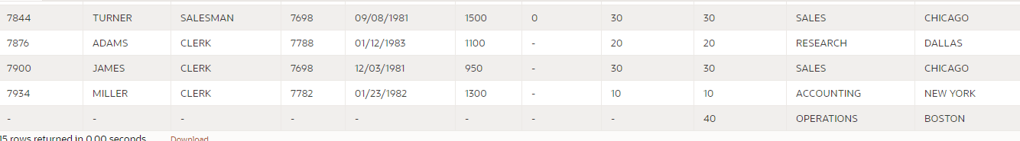

## LEFT OUTER JOIN

SELECT A.*, B.* FROM

DEPT B LEFT OUTER JOIN (SELECT * FROM EMP WHERE JOB = ‘SALESMAN’) A

ON A.DEPTNO = B.DEPTNO

## SELFJOIN List of all Employees with their Respective Manager

SELECT E.EMPNO EMP_ID, E.ENAME EMP_NAME, E.MGR MGR_ID, M.ENAME MGR_NAME

FROM EMP E, EMP M

WHERE E.MGR = M.EMPNO

ORDER BY E.EMPNO

Or

SELECT E.EMPNO EMP_ID, E.ENAME EMP_NAME, E.MGR MGR_ID, M.ENAME MGR_NAME

FROM EMP E JOIN EMP M

ON E.MGR = M.EMPNO

ORDER BY E.EMPNO

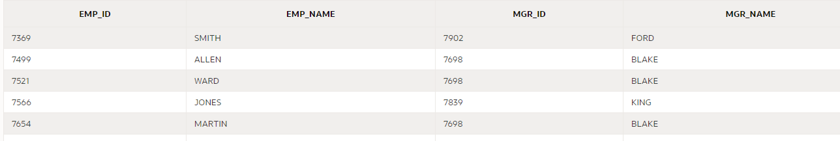

## NO Join, Cartesian product

SELECT * FROM EMP, DEPT -> It will give Cartesian product of Each row of EMP multiplied with each row of DEPT

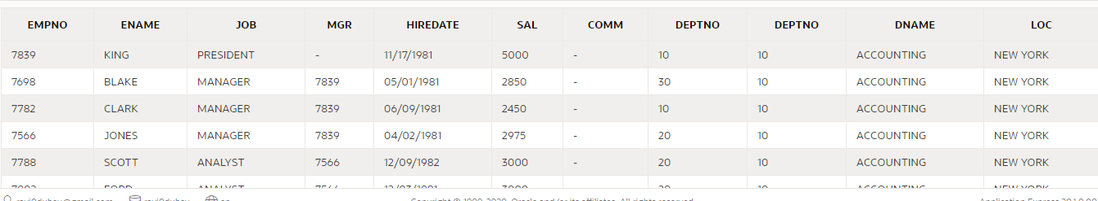

## Natural Join: it is inner join without explicitly mentioning field on which join is done, provided field name remains same in both the files

SELECT * FROM EMP NATURAL JOIN DEPT

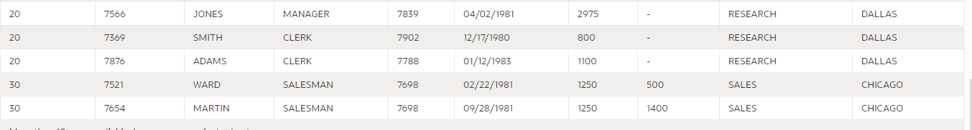

## Using in Join:

SELECT * FROM EMP JOIN DEPT USING (DEPTNO)

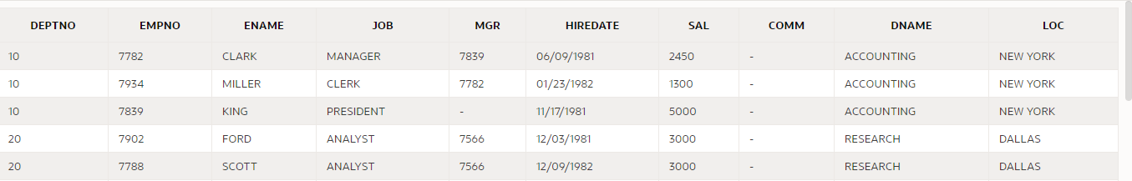

## EQUI Join: it uses equal to in select statement

SELECT E.EMPNO EMP_ID, E.ENAME EMP_NAME, E.MGR MGR_ID, M.ENAME MGR_NAME

FROM EMP E JOIN EMP M

ON E.MGR = M.EMPNO

ORDER BY E.EMPNO

## NON EQUI Join: when there is no common field between 2 tables

SELECT E.NAME, E.SAL, J.GRADE_LEVEL

FROM EMP E JOIN JOB_GRADE J

ON E.SAL BETWEEN J.LOWESTSAL AND J.HIGHEST_SAL

## Case Select

SELECT ENAME, SAL,

(Case WHEN SAL > 1500 THEN 'MANAGER11'

ELSE 'NO COMMENT'

END)

AS "COMMENT_PEAK"

FROM EMP

## Correlated Sub query to showcase number of people working in same DEPTNO

SELECT E.*,

(SELECT COUNT (*)

FROM EMP

WHERE DEPTNO = E.DEPTNO) AS COUNT_DEPT

FROM EMP E

OR

SELECT E.*, COUNT (*) OVER (PARTITION BY DEPTNO) AS COUNT_DEPT

FROM EMP E

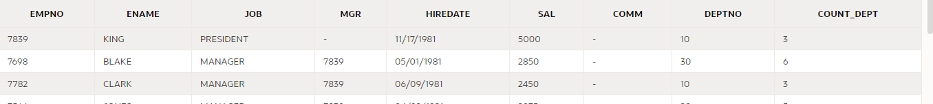

## Correlated Sub query to showcase Total SALARY of people working in same DEPTNO

SELECT E.*,

(SELECT COUNT (*)

FROM EMP

WHERE DEPTNO = E.DEPTNO) AS COUNT_DEPT,

(SELECT SUM (SAL) FROM EMP

WHERE DEPTNO = E.DEPTNO) AS SUM_DEPT

FROM EMP E

OR

SELECT E.*, SUM (SAL) OVER (PARTITION BY DEPTNO) AS COUNT_DEPT

FROM EMP E

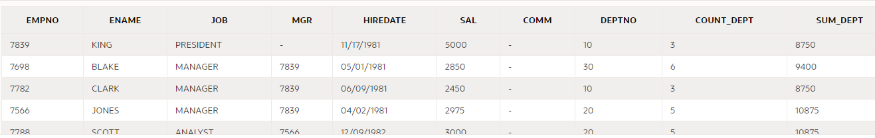

SELECT E.*, SUM (SAL) OVER (PARTITION BY JOB ORDER BY EMPNO) AS COUNT_DEPT

FROM EMP E

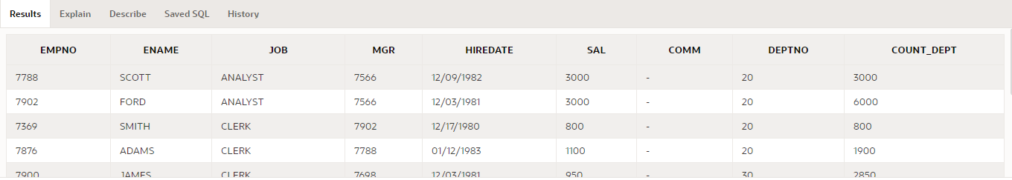

## INSERT ALL – It will insert into different tables, values based on condition given below

INSERT ALL

WHEN SAL <= 1000 THEN

INTO DEST_TBL_1 VALUES (EMPNO, ENAME, HIREDATE)

WHEN SAL BETWEEN 1001 AND 3000 THEN

INTO DEST_TBL_2 VALUES (EMPNO, ENAME, HIREDATE)

ELSE

--WHEN SAL > 3000 THEN

INTO DEST_TBL_3 VALUES (EMPNO, ENAME, HIREDATE)

SELECT EMPNO, ENAME, HIREDATE, SAL

FROM EMP

alter table dest_tbl_3

modify

(empid number,

Empname varchar2(50) ,

date_of_hire date,

constraint pk_key1 primary key(empid)

)

## MERGE

MERGE INTO EMPLOYEE E1

USING EMP E2

ON (E1.EMPNO = E2.EMPNO)

WHEN MATCHED THEN

UPDATE SET

E1.EMPNO = E2.EMPNO,

E1.ENAME = E2.ENAME,

E1.SAL = E2.SAL,

E1.MANAGER = E2.MGR

WHEN NOT_MATCHED THEN

INSERT (E1.EMPNO, E1.ENAME, E1.SAL, E1.MANAGER)

VALUES (E2.EMPNO, E2.ENAME, E2.SAL, E2.MGR);

## SEQUENCE

## CREATE SEQUENCE EMPLOYEE_SEQ

MINVALUE 1

MAXVALUE 9999

START WITH 1

INCREMENT BY 2

CACHE 20;

SELECT EMPLOYEE_SEQ.NEXTVAL FROM DUAL;

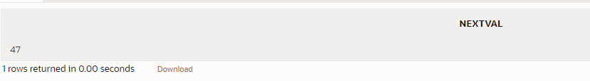

ALTER SEQUENCE EMPLOYEE_SEQ

NOCACHE;

## TRUNCATE

TRUNCATE TABLE EMP

## INDEX

Create Index

CREATE INDEX EMP_ENAME_IDX

ON EMPLOYEE (ENAME);

Create Unique Index-> Field on which index is created has to be unique with no duplicate keys

CREATE UNIQUE INDEX EMP_MANAGER_IDX

ON EMPLOYEE (MANAGER);

Create Index with Compute Statistics

CREATE INDEX EMP_MANAGER_SAL_IDX

ON EMPLOYEE (MANAGER, SAL)

COMPUTE STATISTICS;

Drop Index

DROP INDEX EMP_MANAGER_IDX;

DROP INDEX EMP_ENAME_IDX;

Alter Index

ALTER INDEX EMP_ENAME_IDX

REBUILD COMPUTE STATISTICS;

## Delete duplicate records from file.

DELETE FROM STORES

WHERE ROWID NOT IN

(SELECT MIN(ROWID)

FROM STORES

GROUP BY STOREID, CITY)

## FETCH.

LIMITED records from file

SELECT * from employee

FETCH FIRST 2 ROWS ONLY

SELECT * from employee

FETCH NEXT 2 ROWS ONLY

Fetch only 5 rows

SELECT E.EMPNO, E.ENAME, E.DEPTNO, E.SAL

FROM EMP E INNER JOIN DEPT D

ON E.DEPTNO = D.DEPTNO

ORDER BY SAL DESC

FETCH NEXT 5 ROWS ONLY;

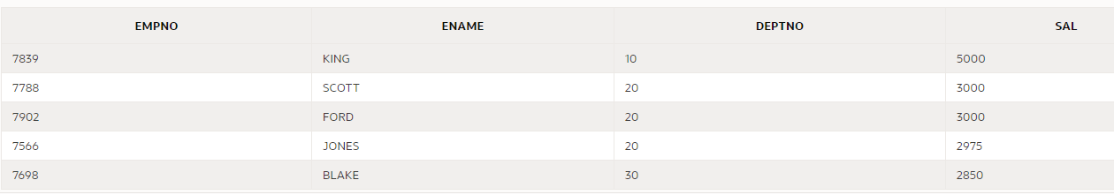

Skip first 5 rows

SELECT E.EMPNO, E.ENAME, E.DEPTNO, E.SAL

FROM EMP E INNER JOIN DEPT D

ON E.DEPTNO = D.DEPTNO

ORDER BY SAL DESC

OFFSET 5 ROWS (In case we give value of offset to negative, it means it will not skip any row)

FETCH NEXT 5 ROWS ONLY;

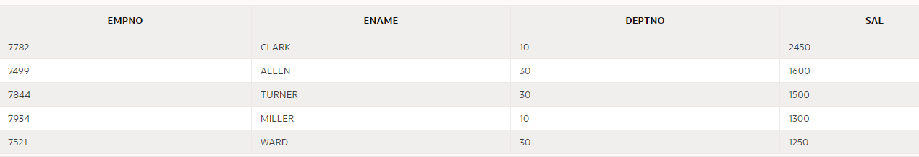

Show first 5 rows with ties will show same salary. Like in below 5th and 6th records had same salary so it show 6 records instead of 5

SELECT E.EMPNO, E.ENAME, E.DEPTNO, E.SAL

FROM EMP E INNER JOIN DEPT D

ON E.DEPTNO = D.DEPTNO

ORDER BY SAL DESC

OFFSET 5 ROWS

FETCH NEXT 5 ROWS WITH TIES;

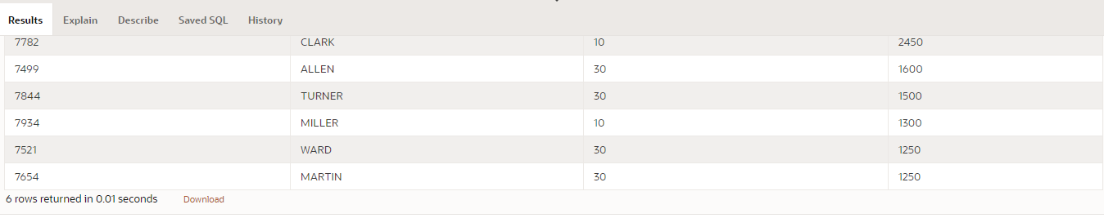

PERCENT rows

SELECT E.EMPNO, E.ENAME, E.DEPTNO, E.SAL

FROM EMP E INNER JOIN DEPT D

ON E.DEPTNO = D.DEPTNO

ORDER BY SAL DESC

OFFSET 5 ROWS

FETCH NEXT 5 PERCENT ROWS ONLY;

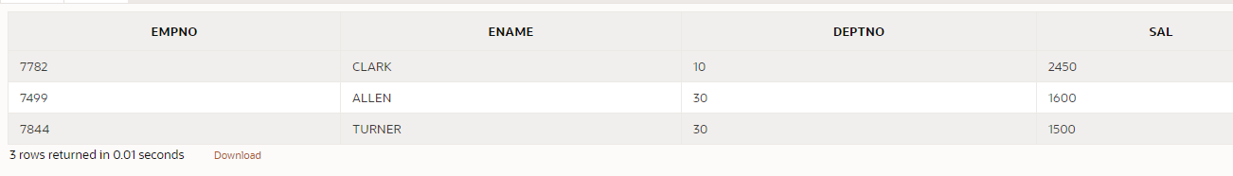

## ALL TABLES

SELECT * FROM ALL_TABLES

WHERE TABLE_NAME = 'EMPLOYEE'

AND ROWNUM < 5



SELECT * FROM ALL_TAB_COLUMNS

WHERE TABLE_NAME = 'EMPLOYEE'

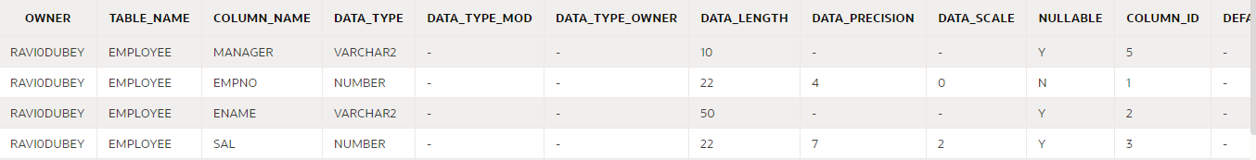

SELECT * FROM ALL_OBJECTS

WHERE OBJECT_TYPE = 'TABLE'

AND OBJECT_NAME = 'EMPLOYEE'



SELECT * FROM ALL_OBJECTS

WHERE OBJECT_TYPE = 'INDEX'

AND OBJECT_NAME = 'EMP_MANAGER_IDX'



## SYNONYM

CREATE SYNONYM EMP_TABLE

FOR EMPLOYEE

SELECT * FROM EMP_TABLE

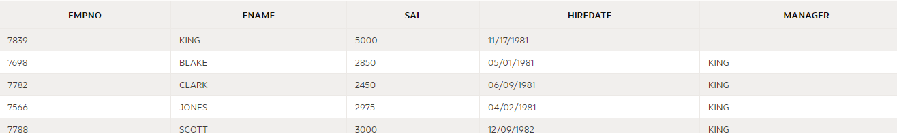

## VIEWS

CREATE VIEW MANAGER_VIEW

AS SELECT * FROM EMPLOYEE

WHERE MANAGER IS NULL

SELECT * FROM MANAGER_VIEW

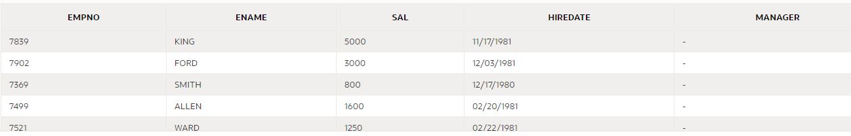

DROP MANAGER_VIEW

Update Existing Views by

CREATE OR REPLACE VIEW MANAGER_VIEW

AS SELECT * FROM EMPLOYEE

WHERE MANAGER IS NULL

## To Retrieve Employee Records with Maximum Salary in their Department

### Approach 1

Step1: Create View to fetch max Salary and Department number of each department

CREATE VIEW MAX_RECORDS_V

AS

SELECT DEPTNO, MAX (SAL) AS MAX_SAL FROM EMP

GROUP BY DEPTNO

Step2: Join Table with View to get Records of Each Employee table from each department

SELECT A.* FROM EMP A JOIN MAX_RECORDS_V M

ON A.DEPTNO = M.DEPTNO

AND A.SAL = M.MAX_SAL

### Approach 2

SELECT E.* FROM EMP E JOIN

(SELECT DEPTNO, MAX (SAL) AS MAX_SAL FROM EMP

GROUP BY DEPTNO) E2

ON E.DEPTNO = E2.DEPTNO

AND E.SAL = E2.MAX_SAL

## To Retrieve Employee Records with Maximum Salary in their Department

SELECT E.EMPNO, E.ENAME, E.DEPTNO, E.SAL

FROM EMP E INNER JOIN DEPT D

ON E.DEPTNO = D.DEPTNO

ORDER BY SAL DESC

FETCH NEXT 5 ROWS ONLY;



## UNION It will give unique records

SELECT * FROM EMP

UNION

SELECT * FROM EMPLOYEES

## UNION ALL it will give all records

SELECT * FROM EMP

UNION ALL

SELECT * FROM EMPLOYEES

## MINUS it will give all records which are not in below table

SELECT * FROM EMP

MINUS

SELECT E.* FROM EMP E JOIN

(SELECT DEPTNO , MAX(SAL) AS MAX_SAL FROM EMP

GROUP BY DEPTNO) E2

ON E.DEPTNO = E2.DEPTNO

AND E.SAL = E2.MAX_SAL

## GRANT

GRANT SELECT ON PRODUCTS TO USER2-> It will grant select authority to user2 on PRODUCTS table of User1

Now User2 can search using SELECT USER1.PRODUCTS

## Revoke

REVOKE SELECT ON PRODUCTS TO USER2-> It will revoke select authority to user2 on PRODUCTS table of User1

## ROLE

CREATE ROLE R1

GRANT P1, P2, P3 TO R1

ALTER USER U1 DEFAULT ROLE R1

## To see user logged in

SHOW USER in SQL

In APEX

SELECT SYS_CONTEXT ('USERENV', 'CURRENT_SCHEMA')

FROM DUAL



## ROLLBACK, COMMIT, SAVEPOINT are part of TCL (Transaction Control Language)

SAVEPOINT serve as an identifier where we can reach using ROLLBACK

ROLLBACK will undo everything to last COMMIT

COMMIT will commit everything.

Implicit COMMIT does happen when Grant, Revoke, Create table command gets executed.

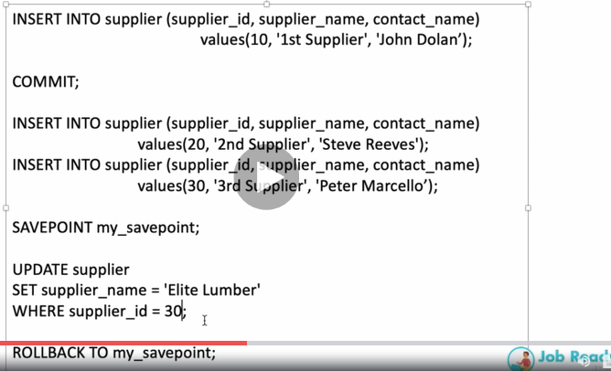

## Cascade Constraints->

It will first remove Constraints and then it will drop the column

ALTER TABLE SUPPLIER DROP COLUMN supplier_id CASCADE CONSTRAINTS

## Cascade Delete-

If record is delete from Parent table is deleted then corresponding record from child table.

Create table with syntax ON DELETE CASCADE

CREATE TABLE products

( product_id numeric(10) not null,

supplier_id numeric(10) not null,

CONSTRAINT fk_supplier

FOREIGN KEY (supplier_id)

REFERENCES supplier(supplier_id)

ON DELETE CASCADE

);

## Column Unused

This command work much faster than Drop Column. If column is set to unused then we cannot query it nor can we retrieve or restore its data.

ALTER TABLE SUPPLIER

SET UNUSED COLUMN SUPPLIER_ID;

OR

ALTER TABLE SUPPLIER

SET UNUSED (SUPPLIER_ID, SUPPLIER_NAME);

Once we wish to finally drop the column, we need to mention below command

ALTER TABLE SUPPLIER

DROP UNUSED COLUMNS;

## To see all Columns marked as Unused

## SELECT * FROM USER_UNUSED_COL_TABS;

## External Tables

## With External tables we can see it as window in oracle, Data is not loaded into Oracle.

When External table are created it create log file in Shared folder. In syntax we use Oracle Loader.We can use Skip records in Syntax to skip how many records we wish to skip while creating external tables

## We cannot

## Use Large Object data type like LOB, CLOB etc.

## Create a constraint

## Change column unused (Oracle will drop it)

## SQL Plus and Substitution Variables

1. Show all -> all system defined variables
2. DEFINE -> ALL user defined variable
3. SET LINESIZE 200 -> It changes line size to 200
4. SET DEFINE OFF -> It will not replace with substituted values
5. PROMPT Hello There -> It will how on terminal value “Hello There”
6. ACCPET VINPUT PROMPT “Give an input” -> it will ask user to enter value which will be stored in VINPUT variable

* Give an input 200
* Prompt Hey there value of VINPUT is : &VINPUT -> it will display line below as

Hey there the value of VINPUT is 200

1. Prompt Hey user give me your name :” value of VINPUT is : &VINPUT

* select * from customer where fname = ‘&VINPUT’

1. select * from customer where fname = &VINPUT

* Enter value for VINPUT: ‘RAVI’ ( It will substitute value entered in above query and execute)
* select * from customer where fname = ‘RAVI’

1. Define vlastname = ‘RAVI’

* Prompt vlastname -> RAVI(it display)
* select * from customer where fname = ‘&VLASTNAME’
* It gets substitute to select * from customer where fname = ‘RAVI’

# Notes

## Oracle does not have LIMIT Clause

## We cannot drop column from a table where we have only one column in it

A table cannot have more than 1000 columns

LOB data type cannot be used as Primary Keys. So DISTINCT, GROUP BY or ORDER BY

|  |  |  |  |
| --- | --- | --- | --- |
| BLOB | Binary Large Object Data type | 4 GB | Image, Video Files |
| CLOB | Character Large Object Data Type | 4 GB | Books, String Sequences, Articles |
| NCLOB |  | 4 GB | Unicode |